**IMPROTING EXCEL DOCUMENT TO ALM**

**Importing requirement from excel.**

**When you install Excel Add-inn to your machine, When you are in excel there is a ALM Section , Click on there and sign in with your ALM username and password**

**Suppose this is your REQUIREMENT DOCUMENT IN EXCEL**

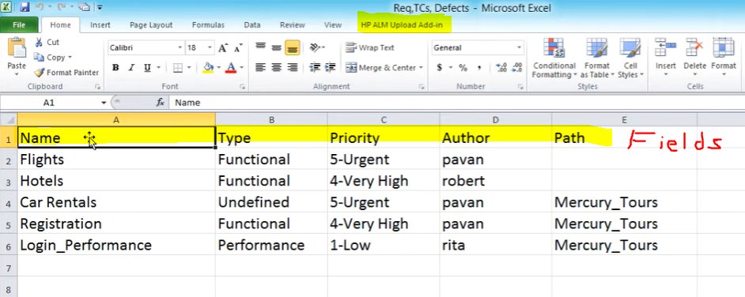

Before you have to Validate all the data in this excel document to be properly defined for ALM.

You need to make sure your Fields and your Requirement type, Priorites should be same as it is in ALM.

Also you need to make sure all the authors should be in your ALM as Users. If not it will not accept it otherwise.

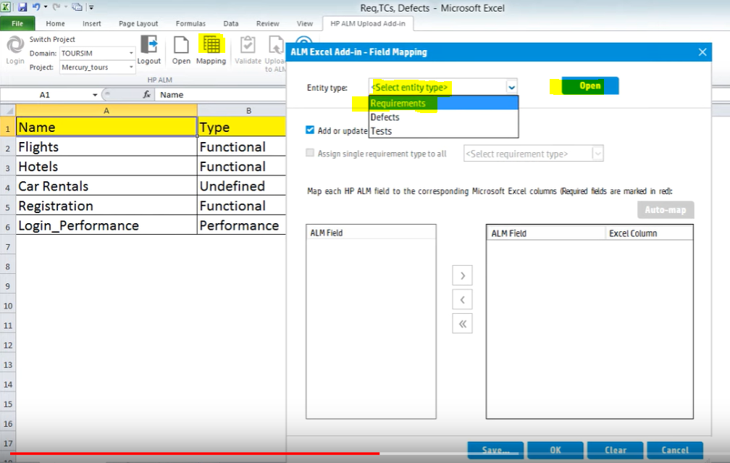

**When you select MAPPING then ALM Window will open, there you select the entity type for this example its Requirements that we are importing.**

**Then it will list all the proper Field Names**

**Also Add the mandatory fields by itself in our example its Name and Requirement type.**

**In our Excel document fields we have are Name, Type, Author, Priority, Path**

**So you can select them one by one and click to arrow icon to relate it to your excel import**

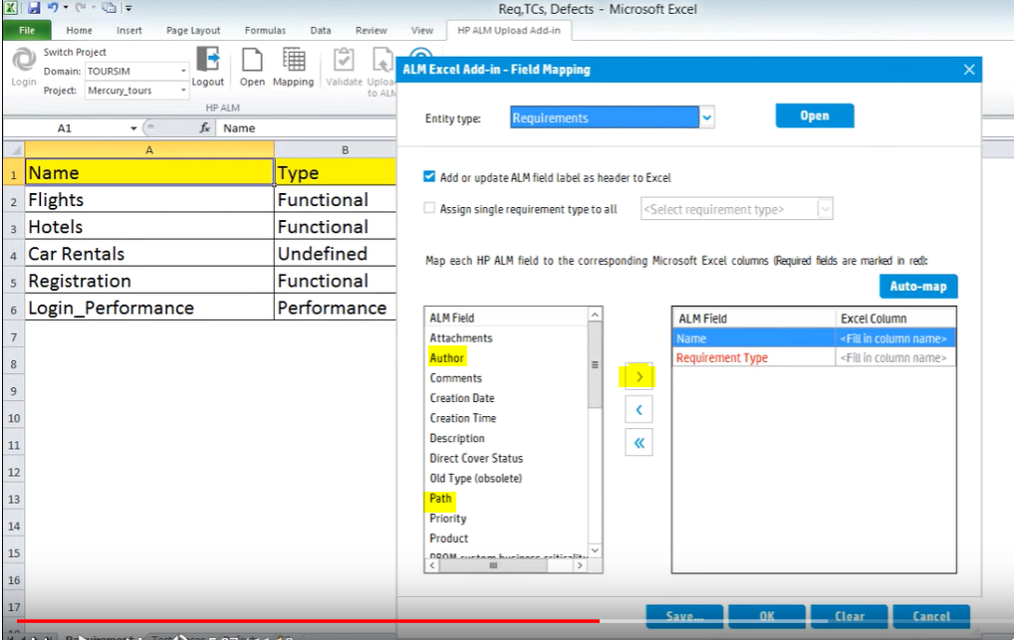

**Or you can Click on Auto-map Button for ALM to try figuring out for you,**

**You have to double check and add what ALM did not add for you.**

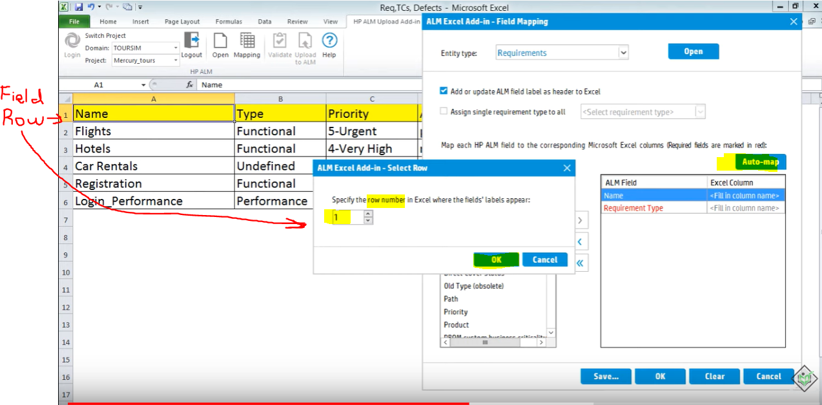

**When you click okay it will try to match the field names and add it itself,**

**In our example excel requirement document, One Field is listed as Type however in ALM it is described as Requirement Type, so We have to fix that.**

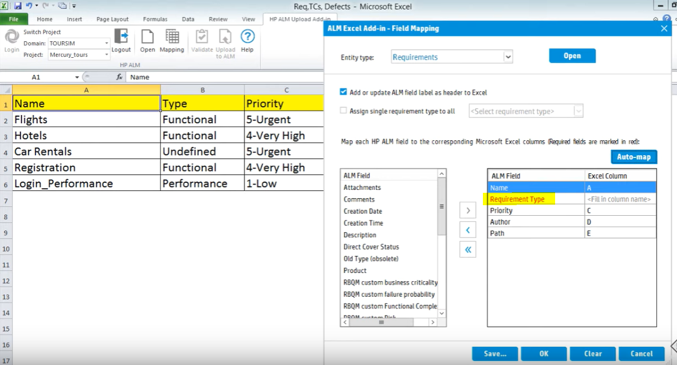

**Just manually type the Column name in this case its B**

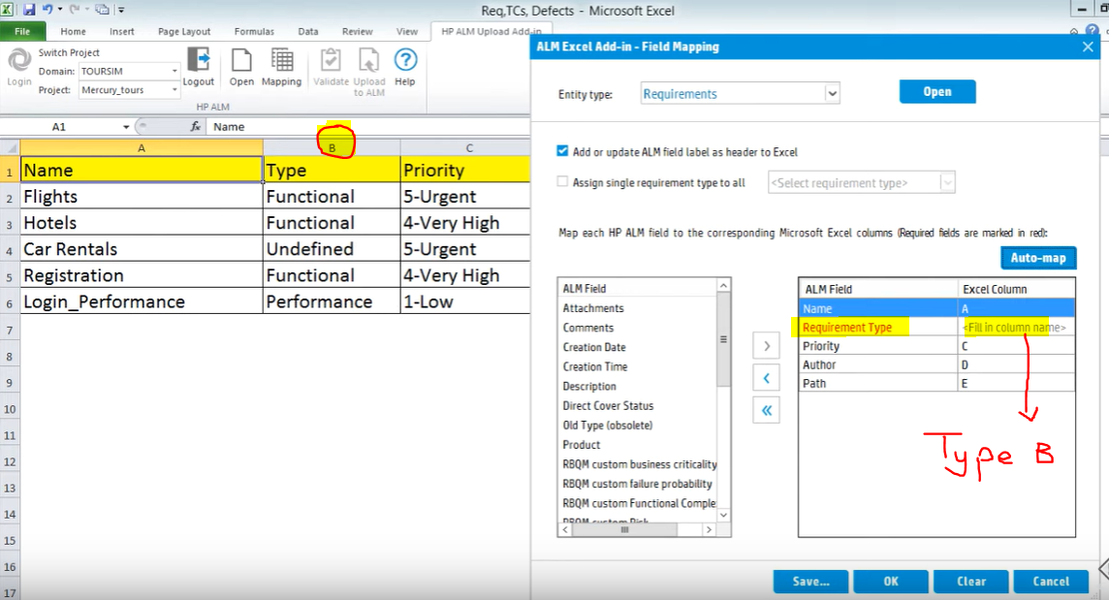

**Click OK**

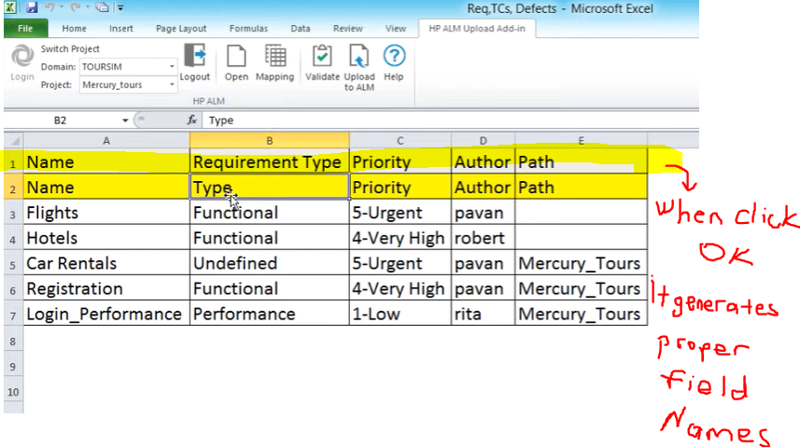

**We completed Mapping our Field names**

**Now We will validate all our inputs**

**As in requirement type should be only one of the ALM Options nothing different it will not accept it otherwise**

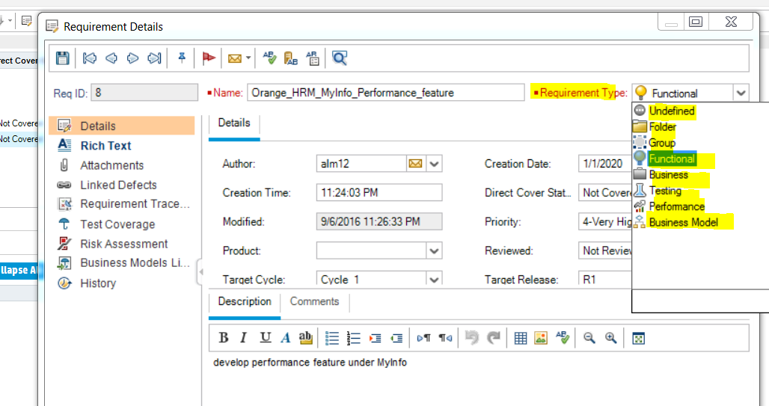

**Author names should be one of the users listed in the ALM it will not accept it otherwise**

**Select all the data and click on Validate it will tell you if anything unmatched with ALM options and you have to fix those**

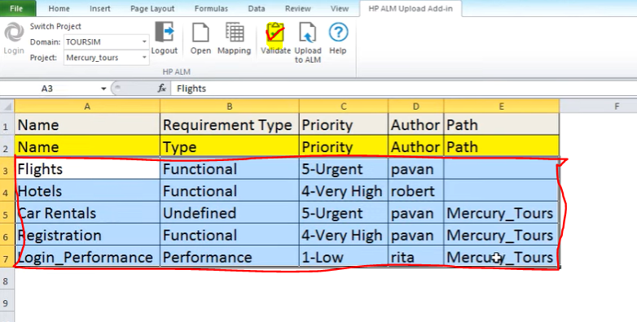

**For Example, Rita is not an user for this requirement so you have to fix it before moving on**

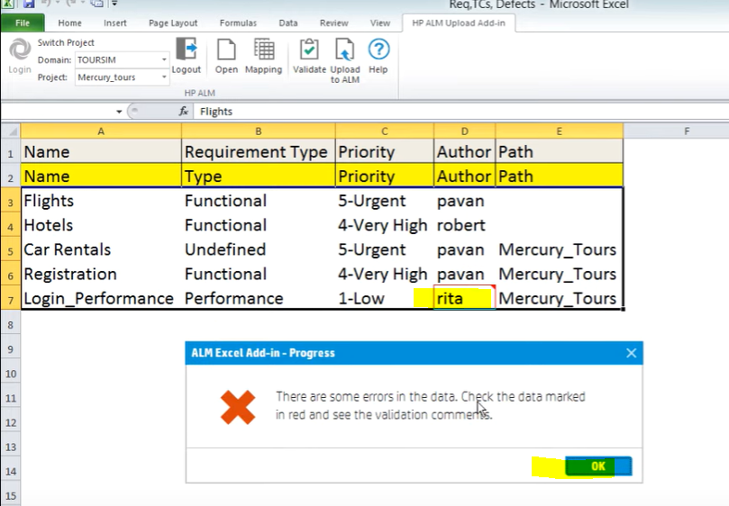

**If you misspell or mistype anything it will not accept it**

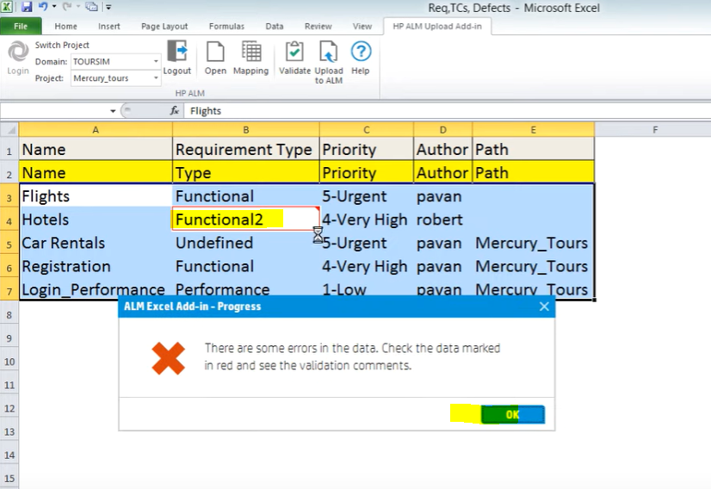

**Once you fix everything it will pass validation.**

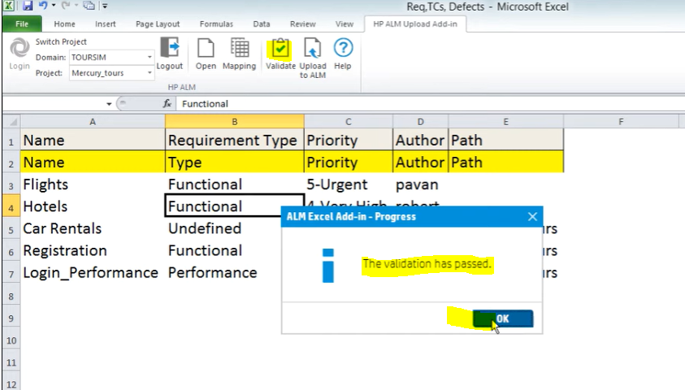

**Then select everthing and click on Upload to ALM**

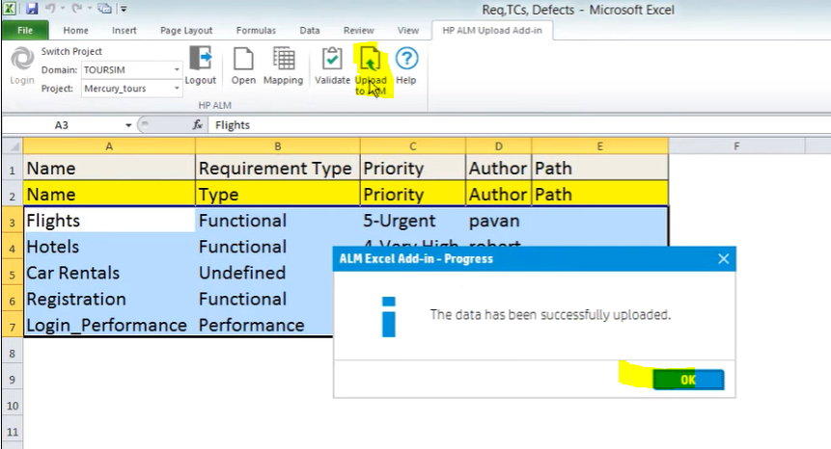

**Then go to ALM and Click refresh icon and data will be imported to your requirements**

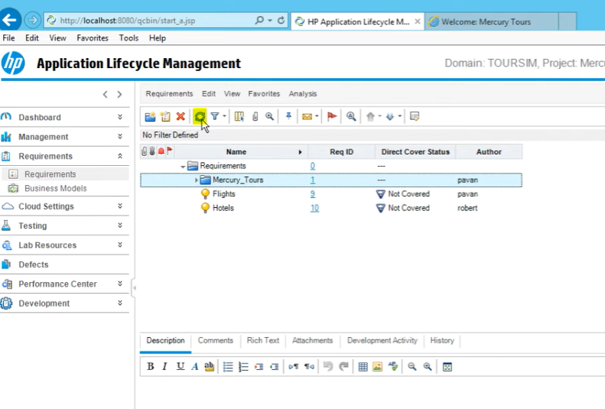

**Path is the Requirement Folder, If you don’t put any input, It is going to put it under general Requirement folder, But later you can drag it inside a folder you want**

